ML Operationts Lifecycle
It includes defining the problem, collecting and preparing data, exploring patterns, engineering features, training and evaluating models, deploying them into production and continuously monitoring performance to handle issues like data drift and retraining needs.

Step 1: Problem Definition
The first step is identifying and clearly defining the business problem. A well-framed problem provides the foundation for the entire lifecycle. Important things like project objectives, desired outcomes and the scope of the task are carefully designed during this stage.
- Collaborate with stakeholders to understand business goals
- Define project objectives, scope and success criteria
- Ensure clarity in desired outcomes

Step 2: Data Collection
Data Collection phase involves systematic collection of datasets that can be used as raw data to train model. The quality and variety of data directly affect the model’s performance.
Here are some basic features of Data Collection:
- Relevance: Collect data should be relevant to the defined problem and include necessary features.
- Quality: Ensure data quality by considering factors like accuracy and ethical use.
- Quantity: Gather sufficient data volume to train a robust model.
- Diversity: Include diverse datasets to capture a broad range of scenarios and patterns.
Data Collection is the systematic process of gathering, measuring and analyzing information from various sources to gain an accurate understanding of a specific topic or problem. It is the first and most fundamental step in research, statistics and data-driven decision-making, as it provides the relevant information needed to answer research questions or solve statistical problems. Accurate data collection ensures reliable results, meaningful insights and informed decisions, while poor or incomplete data can lead to misleading analysis and incorrect conclusions.
The main objectives of data collection are:
- To support decision-making.
- To identify trends and patterns.
- To measure performance and progress.
- To provide evidence for conclusions.
In simple terms, it is the process of gathering facts and figures to discover the truth using statistical methods.

Methods of Collecting Data

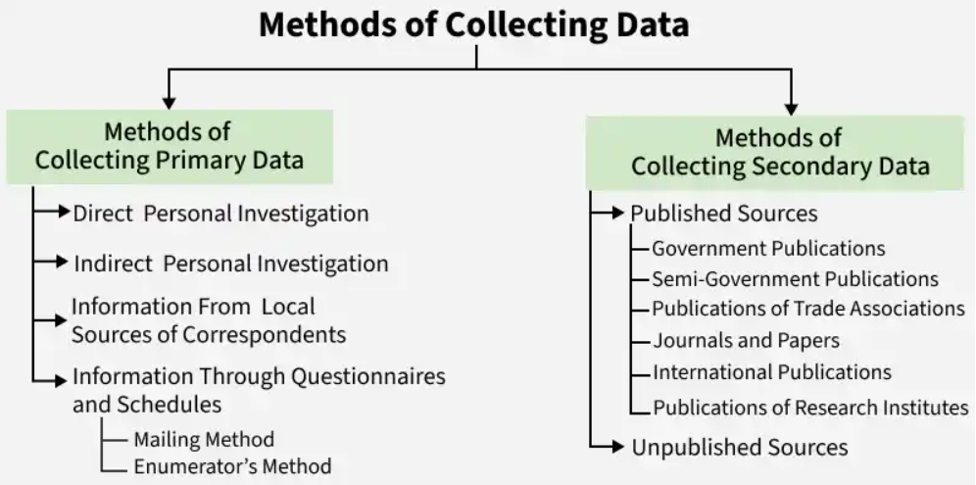

Step 3: Data Cleaning and Preprocessing
Raw data is often messy and unstructured and if we use this data directly to train then it can lead to poor accuracy. We need to do data cleaning and preprocessing which often involves:
- Data Cleaning: Address issues such as missing values, outliers and inconsistencies in the data.
- Data Preprocessing: Standardize formats, scale values and encode categorical variables for consistency.
- Data Quality: Ensure that the data is well-organized and prepared for meaningful analysis.

Step 4: Exploratory Data Analysis (EDA)
To find patterns and characteristics hidden in the data Exploratory Data Analysis (EDA) is used to uncover insights and understand the dataset's structure. During EDA patterns, trends and insights are provided which may not be visible by naked eyes. This valuable insight can be used to make informed decision.
Here are the basic features of Exploratory Data Analysis:
- Exploration: Use statistical and visual tools to explore patterns in data.
- Patterns and Trends: Identify underlying patterns, trends and potential challenges within the dataset.
- Insights: Gain valuable insights for informed decisions making in later stages.
- Decision Making: Use EDA for feature engineering and model selection.

Step 5: Feature Engineering and Selection
Feature engineering and selection is a transformative process that involve selecting only relevant features to enhance model efficiency and prediction while reducing complexity.
Here are the basic features of Feature Engineering and Selection:
- Feature Engineering: Create new features or transform existing ones to capture better patterns and relationships.
- Feature Selection: Identify subset of features that most significantly impact the model's performance.
- Domain Expertise: Use domain knowledge to engineer features that contribute meaningfully for prediction.
- Optimization: Balance set of features for accuracy while minimizing computational complexity.

Step 6: Model Selection
For a good machine learning model, model selection is a very important part as we need to find model that aligns with our defined problem, nature of the data, complexity of problem and the desired outcomes.
Here are the basic features of Model Selection:
- Complexity: Consider the complexity of the problem and the nature of the data when choosing a model.
- Decision Factors: Evaluate factors like performance, interpretability and scalability when selecting a model.
- Experimentation: Experiment with different models to find the best fit for the problem.

Step 7: Model Training
With the selected model the machine learning lifecycle moves to model training process. This process involves exposing model to historical data allowing it to learn patterns, relationships and dependencies within the dataset.
Here are the basic features of Model Training:
- Iterative Process: Train the model iteratively, adjusting parameters to minimize errors and enhance accuracy.
- Optimization: Fine-tune model to optimize its predictive capabilities.
- Validation: Rigorously train model to ensure accuracy to new unseen data.

Step 8: Model Evaluation and Tuning
Model evaluation involves rigorous testing against validation or test datasets to test accuracy of model on new unseen data. It provides insights into model's strengths and weaknesses. If the model fails to acheive desired performance levels we may need to tune model again and adjust its hyperparameters to enhance predictive accuracy.
Here are the basic features of Model Evaluation and Tuning:
- Evaluation Metrics: Use metrics like accuracy, precision, recall and F1 score to evaluate model performance.
- Strengths and Weaknesses: Identify the strengths and weaknesses of the model through rigorous testing.
- Iterative Improvement: Initiate model tuning to adjust hyperparameters and enhance predictive accuracy.
- Model Robustness: Iterative tuning to achieve desired levels of model robustness and reliability.

Step 9: Model Deployment
Now model is ready for deployment for real-world application. It involves integrating the predictive model with existing systems allowing business to use this for informed decision-making.
Here are the basic features of Model Deployment:
- Integrate with existing systems
- Enable decision-making using predictions
- Ensure deployment scalability and security
- Provide APIs or pipelines for production use

Step 10: Model Monitoring and Maintenance
After Deployment models must be monitored to ensure they perform well over time. Regular tracking helps detect data drift, accuracy drops or changing patterns and retraining may be needed to keep the model reliable in real-world use.
Here are the basic features of Model Monitoring and Maintenance:
- Track model performance over time
- Detect data drift or concept drift
- Update and retrain the model when accuracy drops
- Maintain logs and alerts for real-time issues

